**Princess Smart Tower Fan**

**Mod.01.350000.01.001**

**Instruction Manual**

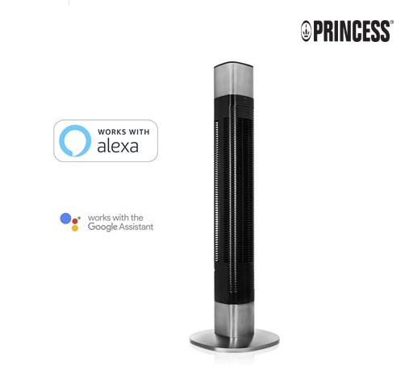

ADVISE: Before the first use read this instructions carefuly, remove all stickers and protective foil.

This producto can be operated in twice modes, **manual mode** (using the top control panel) and **Smart mode** (using the Smart control app and Amazon Alexa or Google Assistant).

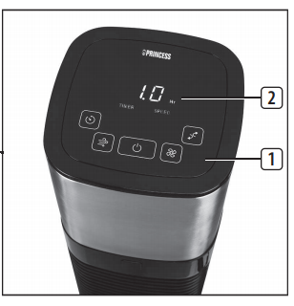**MANUAL MODE.**

First press the **On/Off button** to turn on the fan, it start to blow in mínimum speed mode. To turn off press same button another time.

 To select the desired blowing, push the **speed button** , pressing several times to select one of three speed modes.

To chose one of three breeze presets (Normal, Natural or Sleep) press the **mode button** ,the selected mode are shown on the display (2).

Press the **oscilation button** to start or stop the swing function, the fan body can rotate in 80º of range .

Press the **timer button** to actívate the count down timer. You can push several times to increase the timer up to 8 hours (mínimum time 1 hour). When count down finish the fan turns off.

**SMART MODE.**

First download HomeWizard Climate App in your smartphone (It runs over 7.0 android versions or latest and IOS 11 or latest) and Then actívate the wifi on your smartphone.

After this you are prepared to pair for fist time your Princess Smart Tower following next instructions (you only need to do this once):

First turn on the fan Tower (see manual mode step one).

Next, on your smartphone, open HomeWizard Climate app. Push on “***Create an account***” and follow the steps (the aplication has a simple wizard to do it).

Following this you can enter by logging your account, and then add your Fan Tower clicking

**ON**

Finally, the app guides you to pair the device, for this click on “Add new Climate Device”.

Once you have paired the device, you can use Fan Tower with Alexa saying

" ALEXA *<your order>* ".

**ORDERS LIST:**

* Turn on (or off) Fan Tower
* Speed to level (one, two or three).

**Enjoy your new Smart Tower fan**. By **Princess** intelligent things.